WAV Audio Guide

The information below will guide you through the process of recording or converting WAV files of the following format for upload to Futiva Customer Administration Portal:

WAV extension
8000khz sample rate
U-Law encoding

Record a voice greeting using an Android phone

Record a voice greeting using an iPhone, iPod Touch or iPad

Record a voice greeting using a Mac or PC

Convert an existing audio file using a Mac or PC

Record a voice greeting using an Android Phone
- Download Broadsoft Recorder from the Google Play Store.
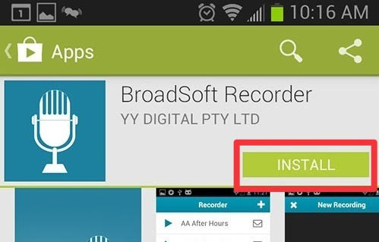
- Open the Broadsoft Recorder app.
- Tap the “plus” icon at the top right corner of the screen.
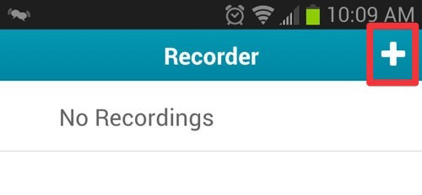
- Tap the “record” button at the bottom of the screen to begin recording.
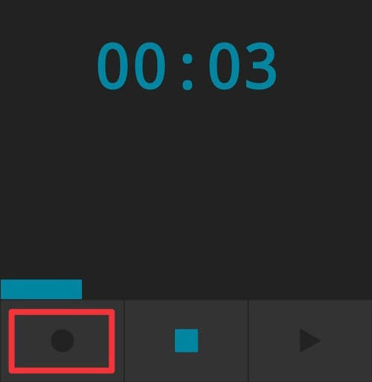
- Tap the “stop” button to pause or complete recording. 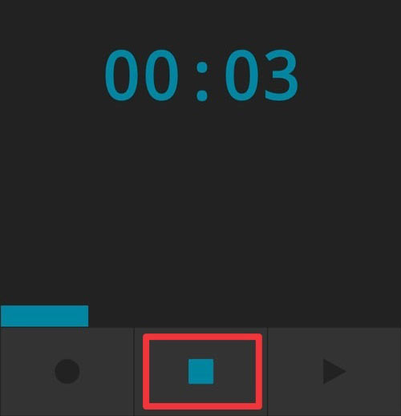

- Tap the “checkmark” button at the top right hand corner of the screen to confirm completion of the recording.
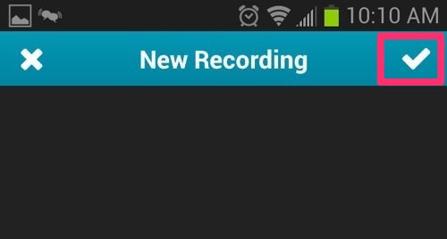
- Name the recording.
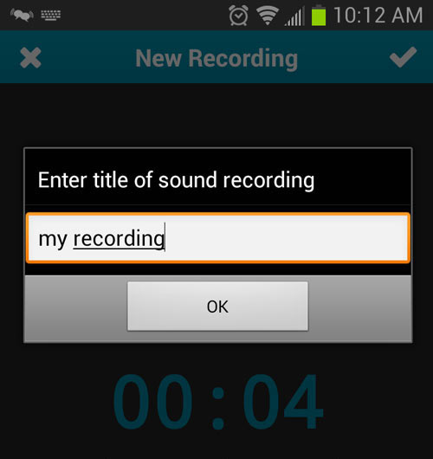
- The new recording will be saved to the phone.
- You can preview the recording by tapping the “play” button to the left of the recording entry.
- Send the WAV file to an email address by tapping the “Envelope” icon to the right of the recording entry. The file will be sent as an attachment for download.
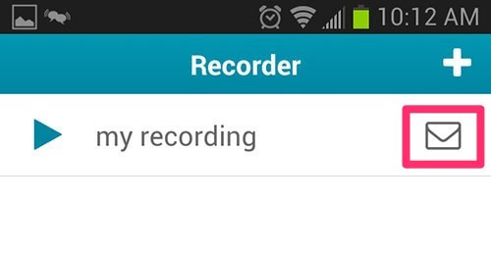
- You should now have a WAV file that you can upload to the Futiva Customer Administration Portal.

Record a voice greeting using an iPhone, iPod Touch or iPad
- Download Broadsoft Recorder from the iTunes Store.
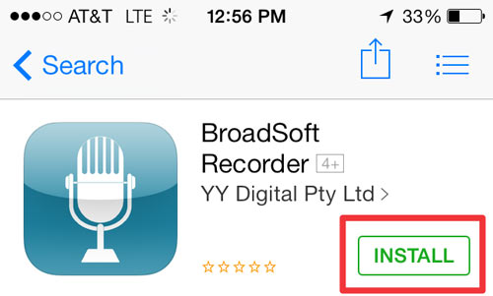
- Open the Broadsoft Recorder app.
- Tap the “plus” icon at the top right corner of the screen.
- Tap the “record” button at the bottom of the screen to begin recording.
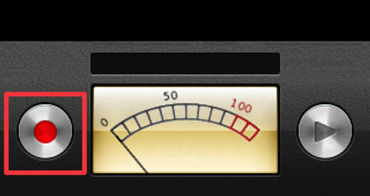
- Tap the “stop” button to complete the recording.
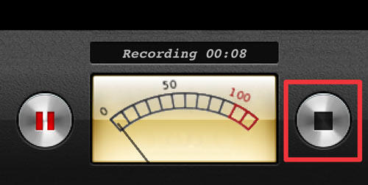
- Tap the “checkmark” button at the top right hand corner of the screen to confirm completion of the recording.
- Name the recording.
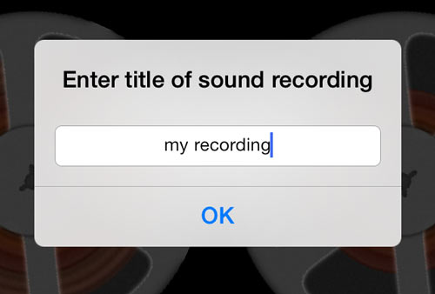
- The new recording will be saved to the phone.
- You can preview the recording by tapping the “play” button to the left of the recording entry.
- Send the WAV file to an email address by tapping the “Envelope” icon to the right of the recording entry. The file will be sent as an attachment for download.
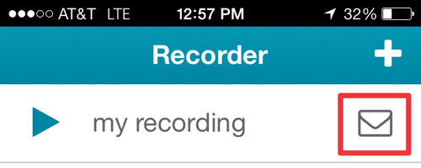
- You should now have a WAV file that you can upload to the Futiva Customer Administration Portal.

Convert an existing audio file using a Mac or PC
- Download and Install Audacity for your operating system
- Open Audacity and click “OK” when asked.
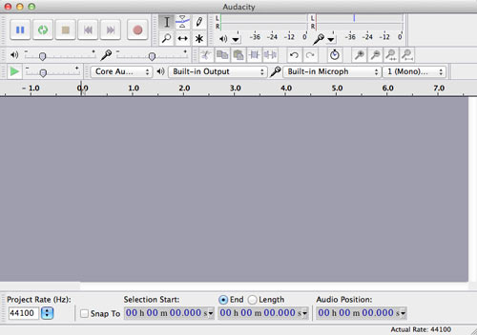

Converting an Existing File
- Go to File > Open and open the audio file to be converted.
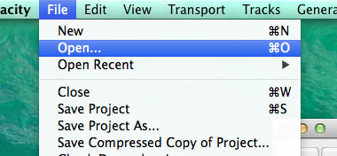
- Set the “Project Rate (Hz)” to 8000.
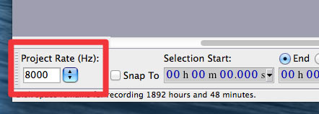
- Go to File > Export to save out the file.
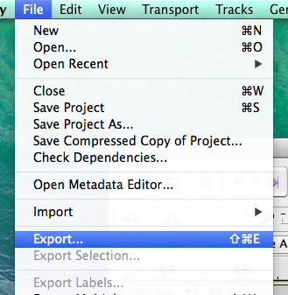

Recording a New File
- Select the audio input you will be recording from.
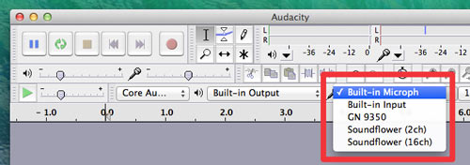
- Set the “Project Rate (Hz)” to 8000.
- Press the “record” button to begin recording.
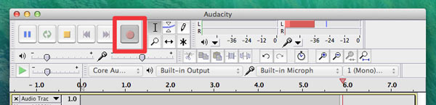
- When finished, press the “stop” button.
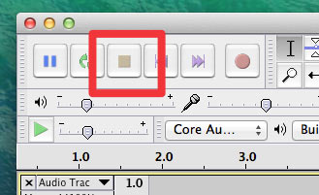
- If you are satisfied with your recording, go to File > Export to save out the file.

Saving out the file
- In the “Format” dropdown menu, select “Other uncompressed files” and then click “Options”.
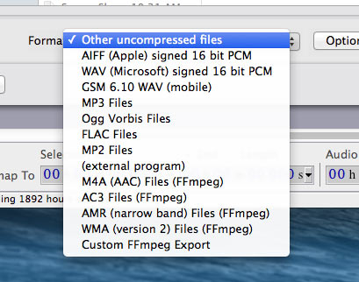
- Under the “Header” dropdown menu, select “WAV (Microsoft)”. Under the “Encoding” dropdown menu, select “U-Law”.
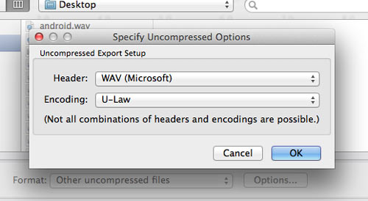
- Select an output location and Click “Save”.
- You now have a WAV file ready for upload to Futiva Online.

